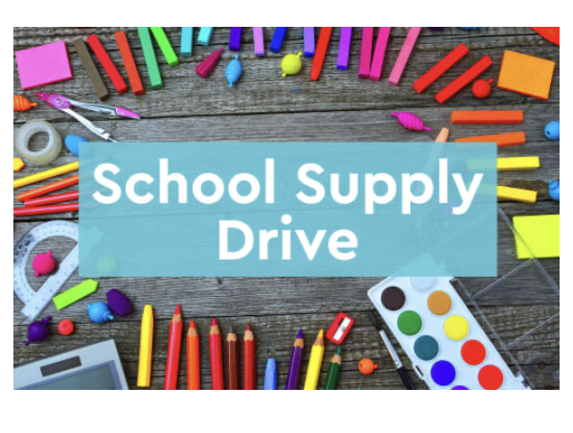

Help Make a Difference!!

Time to clean out your desks because Horizons Kids needs our help to fill their summer camp classrooms with new/unused school supplies.

Boxes of Pencils/Pens Glitter/beads

Boxes of Markers/Crayons Highlighters

Boxes of Colored Pencils Tubs of Play-Doh

Notebooks Fidgets– sensory toys/spinners

Packs of Construction Paper Stickers

Glue Sticks Elmer’s Liquid Glue

Folders